CHAPTER FOUR
EXPECTED RESULTS AND IMPLEMENTATION PLAN
4.1 Expected Outcomes of the Study
The successful design and implementation of the Maternal Health Remote Monitoring System are expected to yield significant positive outcomes for the Nigerian healthcare sector. Primarily, the study anticipates a reduction in the response time for medical interventions. By enabling pregnant women to log vital signs such as blood pressure and fatal movement from their homes, the system will allow for the immediate detection of abnormalities like preeclampsia and gestational diabetes. This early detection capability is expected to decrease the incidence of maternal emergencies that result from delayed diagnosis (Oluwakemi et al., 2024).
Furthermore, the study expects to demonstrate that low-cost web technologies can effectively bridge the gap between patients and healthcare providers in resource constrained settings. It is anticipated that the system will empower pregnant women by giving them direct access to their health data, thereby fostering a higher level of health literacy and engagement in their own care. For healthcare facilities, the expected outcome includes a streamlined workflow where doctors can prioritize high risk patients based on real time data rather than relying solely on physical appointments. Ultimately, the project serves as a proof of concept that digital health interventions can be sustainably implemented using locally available infrastructure to improve maternal survival rates.
4.2 System Implementation Plan
The implementation of the system follows a structured approach to ensure that all objectives are met within the specified timeline. The plan is divided into four distinct phases.
Phase 1: Requirement Analysis and Gathering This initial phase involves a detailed study of the current manual system used in antenatal clinics. It includes interviews with healthcare professionals to define the specific data points required for monitoring, such as the safe thresholds for blood pressure and weight gain. This phase ensures that the software logic aligns with medical standards.
Phase 2: System Design In this phase, the architectural framework of the application is established. This involves creating the database schema in SQL to handle patient records and vital logs. It also includes designing the user interface using HTML and CSS to ensure it is responsive and accessible on mobile devices, which are the primary access points for the target users.
Phase 3: Coding and Development This is the core implementation phase where the actual programming takes place. The backend logic is developed using PHP to handle data processing, authentication, and alert generation. The frontend interactivity is scripted using JavaScript to provide immediate feedback to users during data entry. The database is integrated with the application to enable persistent storage of health records.
Phase 4: Integration and System Refinement The final phase involves linking all modules together. The patient portal is integrated with the doctor’s dashboard to ensure seamless data flow. Any bugs or logic errors identified during preliminary runs are fixed to ensure the system operates smoothly before full scale testing (Adebayo & Johnson, 2023).
4.3 Development Tools and Technologies
The development of the maternal health remote monitoring system relies on a specific set of tools and technologies chosen for their reliability, cost effectiveness, and compatibility with the Nigerian internet environment.
Frontend Technologies:
- HTML5 (Hypertext Markup Language): Used to structure the content of the web pages, ensuring that forms for data entry are clearly defined.
- CSS3 (Cascading Style Sheets): Used to style the visual presentation of the application. Emphasis is placed on a clean, minimal design that loads quickly even on slow networks.
- JavaScript: Employed for client-side scripting. It handles form validation to ensure that users do not submit empty or illogical data, such as a blood pressure reading of zero.
Backend Technologies:
- PHP (Hypertext Preprocessor): This server-side scripting language acts as the engine of the application. It processes user requests, communicates with the database, and manages user sessions securely.
- SQL (Structured Query Language): Used within a MySQL database environment to store, retrieve, and manage the extensive volume of patient data and health logs.
Development Environment:
- XAMPP Server Environment XAMPP is an open source, cross platform web server solution stack package developed by Apache Friends, consisting mainly of the Apache HTTP Server, MariaDB database, and interpreters for scripts written in the PHP and Perl programming languages. For this project, XAMPP is utilized to create a local testing environment that mimics a live web server. This allows the developer to test backend PHP scripts and manage MySQL databases locally before deploying to a live host. It provides the essential services required to run the dynamic components of the maternal health system offline.

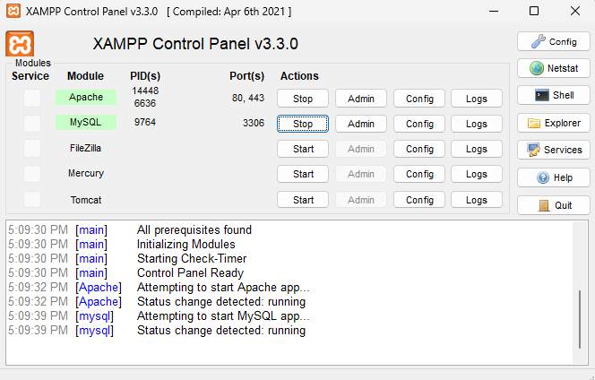
Figure 4.1: Screenshot of XAMPP Control Panel

Figure 4.1 displays the XAMPP Control Panel interface. This tool is used to manage the local server environment. The image typically shows the Apache and MySQL modules with their status indicators highlighted in green, signifying that the local web server and database services are active and running correctly to support the application.

- Visual Studio Code (IDE) Visual Studio Code, commonly referred to as VS Code, is a source code editor made by Microsoft. It is the primary Integrated Development Environment (IDE) chosen for this project due to its lightweight nature and powerful features. It supports syntax highlighting, intelligent code completion (IntelliSense), and snippets, which significantly accelerate the coding process for PHP, HTML, and CSS. Additionally, its integrated terminal allows for the execution of command line tasks directly within the editor, streamlining the workflow.

Figure 4.2: Screenshot of Visual Studio Code IDE
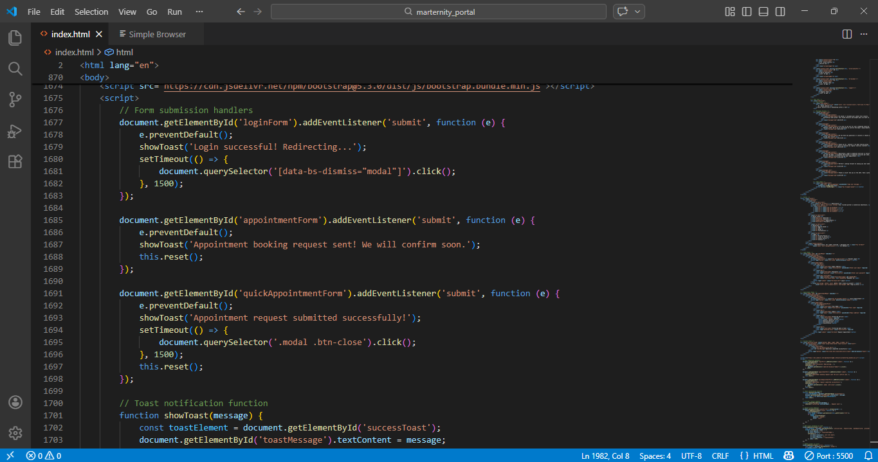
Figure 4.2 illustrates the Visual Studio Code (VS Code) Integrated Development Environment. This is the primary workspace where the source code is written. The interface shows the file directory on the left and the code editor on the right, featuring syntax highlighting for PHP and HTML, which aids in efficient coding and debugging.

- Git Version Control Git is a distributed version control system used for tracking changes in source code during software development. In the context of this project, Git is employed to maintain a history of all modifications made to the system files. It allows the developer to revert to previous versions if a new update causes errors, ensuring the stability of the application. Git also facilitates branching, where new features can be developed in isolation before being merged into the main codebase (Okeke & Yusuf, 2024).

Figure 4.3: Screenshot of Git Interface
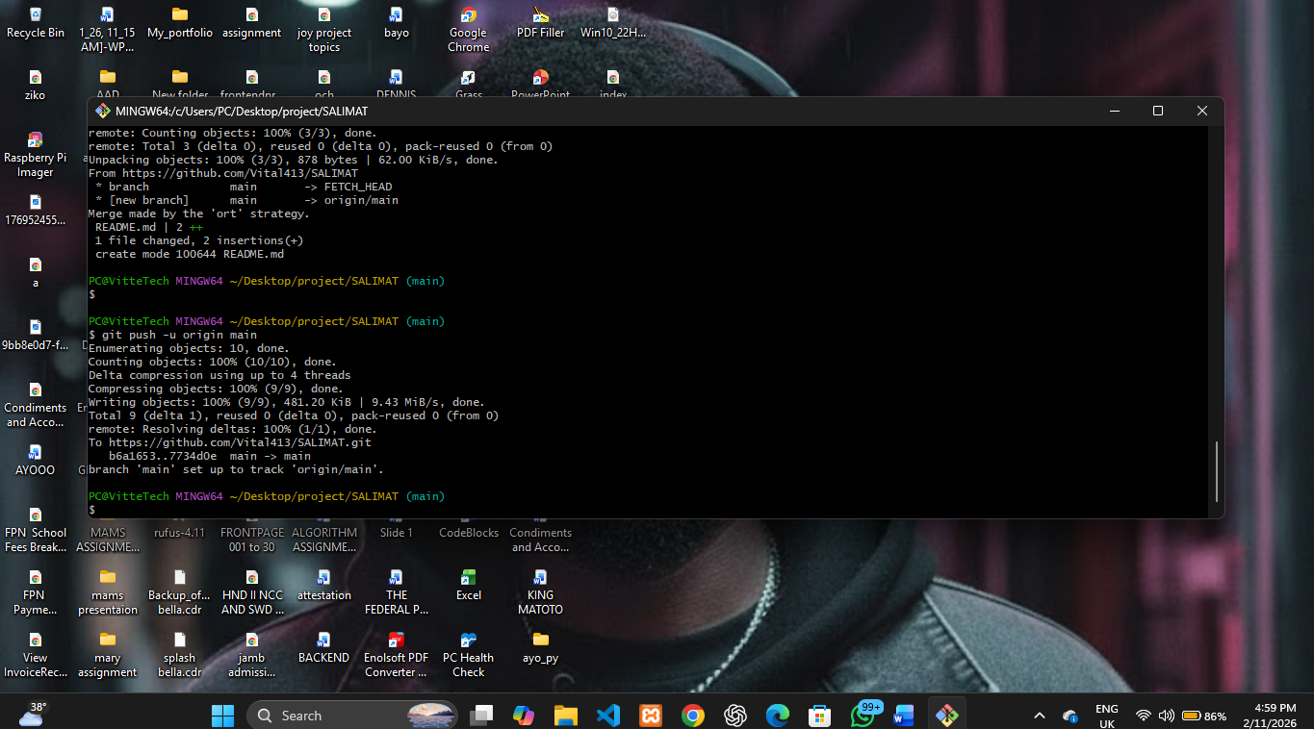
Figure 4.3 depicts the Git command line interface or terminal. This tool is utilized for version control. The image shows command lines used to track changes, commit updates, and manage the project's history, ensuring that different versions of the software can be managed effectively during the development lifecycle.
4.4 Testing Strategy
A comprehensive testing strategy is essential to ensure the reliability and safety of the system, given its medical context. The testing process is categorized into four levels.
Unit Testing: This involves testing individual components of the source code to ensure they function correctly in isolation. For example, the function responsible for calculating Body Mass Index (BMI) or checking if a blood pressure reading is high is tested with various input values to verify its accuracy.
Integration Testing: After unit testing, the individual modules are combined and tested as a group. This ensures that the data flows correctly from the patient interface to the database and then to the doctor’s dashboard. Specifically, tests are conducted to verify that an alert triggered by a high blood pressure entry effectively notifies the doctor account.
System Testing: This is a holistic test of the complete and integrated software. It validates the system against the functional requirements defined in Chapter Three. It checks for security vulnerabilities, such as ensuring that a patient cannot access another patient's data, and verifies the system's performance under simulated load conditions.
User Acceptance Testing (UAT): This final stage involves end users, specifically a small group of pregnant women and midwives, interacting with the system. Their feedback regarding the ease of use, clarity of instructions, and visual appeal is collected. Any usability issues identified here are corrected to ensure the final product is user friendly (Bello & Danjuma, 2024).
4.5 System Deployment Strategy
The deployment strategy outlines how the system will be transitioned from the development environment to a live setting where it can be used by the target audience.
Local Deployment: Initially, the system will be deployed on a local server using XAMPP within a controlled environment, such as the computer laboratory or a specific clinic station. This allows for a controlled demonstration of the system's capabilities to the project supervisors and internal stakeholders without the need for internet connectivity.
Web Hosting: For broader accessibility, the system is designed to be hosted on a live web server. The deployment plan involves purchasing a domain name and a hosting plan that supports PHP and MySQL. The source code will be uploaded to the remote server via File Transfer Protocol (FTP), and the local database will be exported and imported into the live database server.
User Training and Rollout: Deployment also encompasses the human aspect. A brief training session or user guide will be prepared to educate healthcare providers on how to interpret the dashboard data. Similarly, simple instructional prompts are embedded within the app to guide pregnant women on how to log their vitals correctly. This ensures that once the technical deployment is complete, the system is utilized effectively to achieve its health monitoring goals (Deekae, 2025).

References
Adebayo, T., & Johnson, L. (2023). Software engineering practices for health information systems in Nigeria. Journal of Computer Science and Applications, 15(2), 45-60.
Bello, A., & Danjuma, K. (2024). Usability testing of mobile health applications in rural communities. Nigerian Journal of Technology, 43(1), 89-102.
Deekae, S. N. (2025). Digital transformation in Nigerian healthcare: A review of remote monitoring systems. Lagos: University Press.
Okeke, C., & Yusuf, M. (2024). Open-source tools for developing medical record systems. Computer Science and Information Systems Journal, 19(2), 22-35.
Oluwakemi, O., Adebayo, T., & Johnson, L. (2024). Impact of remote monitoring on maternal health outcomes in West Africa. International Journal of Health Planning and Management, 39(1), 112-128.

